**CP3407 ASSESSMENT TASK 2: Project Plan**

**GROUP 2**

**Lecturer: Da Sheng Liu**

**GITHUB link:** [**https://github.com/kkw123/CP3407_Assignment**](https://github.com/kkw123/CP3407_Assignment)

**This assignment is done by two students.**

|  |  |  |
| --- | --- | --- |
| **Student name** | **Student ID** | **Project role** |
| Tan Jia Qi | 13671065 | Scrum Master,  member,  project developer,  Website developer,  User stories,  Interface design,  Database design,  Website owner,  Project research |
| Kum King Wye | 13414829 | Scrum Master,  member,  project developer,  Website developer,  User stories,  Interface design,  Database design,  Website owner |

**Report the ACTUALLY delivered alpha-release**

1. **Any deviations from the alpha-release-iteration-1**

|  |  |  |
| --- | --- | --- |
| **Test modules depends on users stories** | **Description** | **Test result** |
| 1. Start up process **-** Users wish to see a neat but comfortable homepage. | Users enter our website link to hire or seek for a job. Our platform will be attractive for people to browse. | Pass |



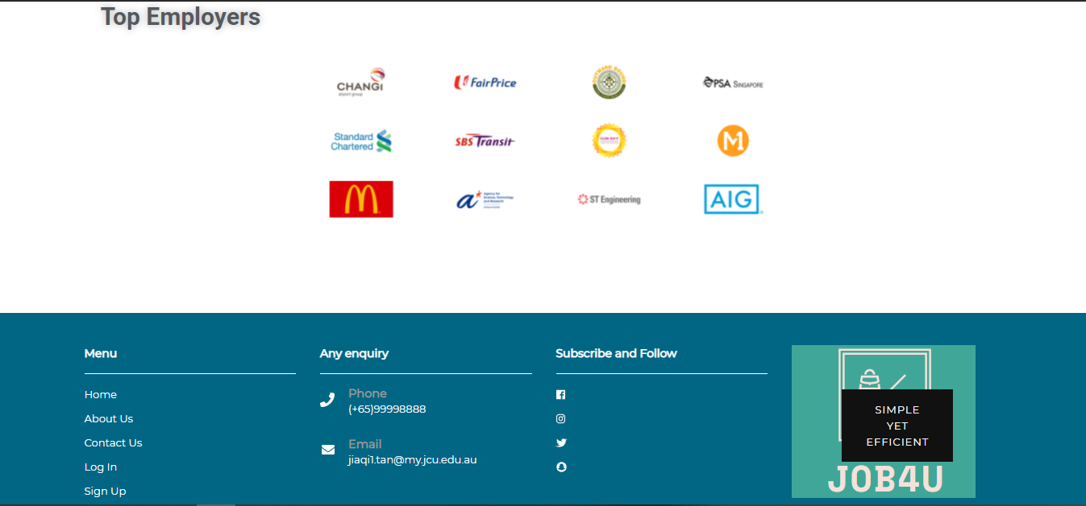

|  |  |  |
| --- | --- | --- |
| 1. Users wish ro sign up to set up their profile. | Sign up page displayed on screen and led users to enter their email and password (recommend strong password) | Pass |

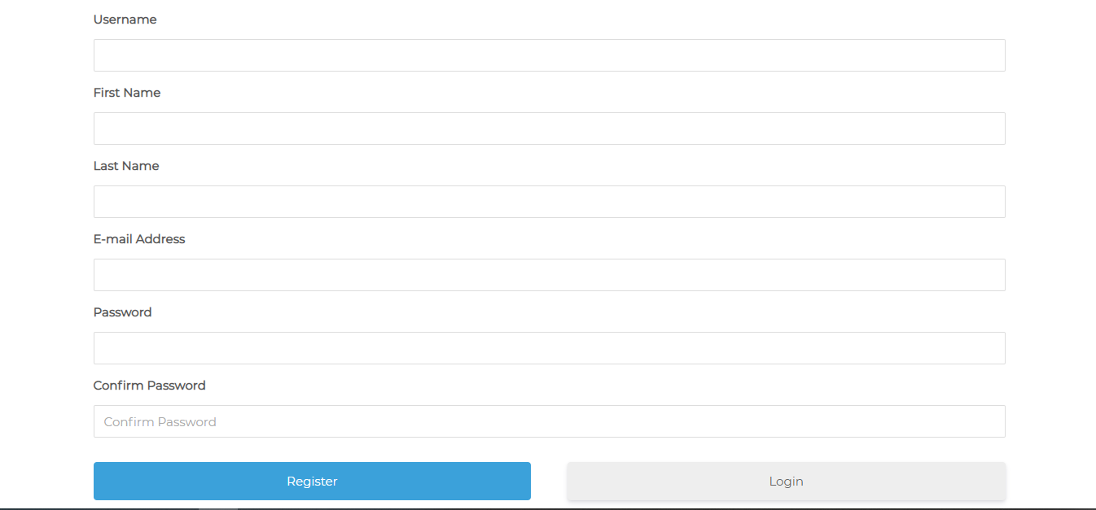

|  |  |  |
| --- | --- | --- |
| 1. Users wish to login and sometimes they will forget their password. | Allows them to login into their profile and when they forget their password, make sure the website sent a verification email to them. | Pass |

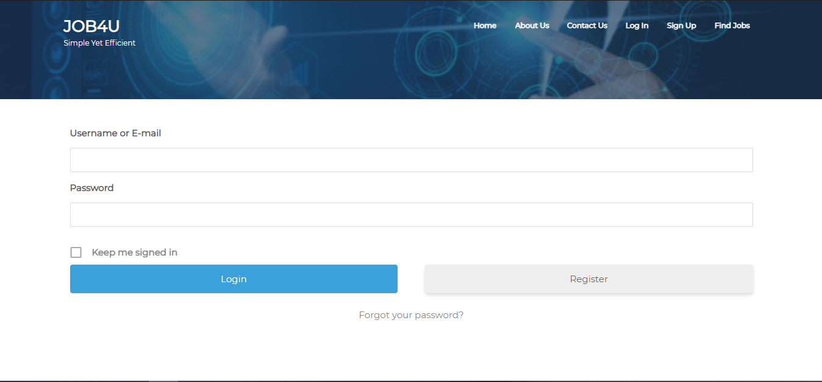

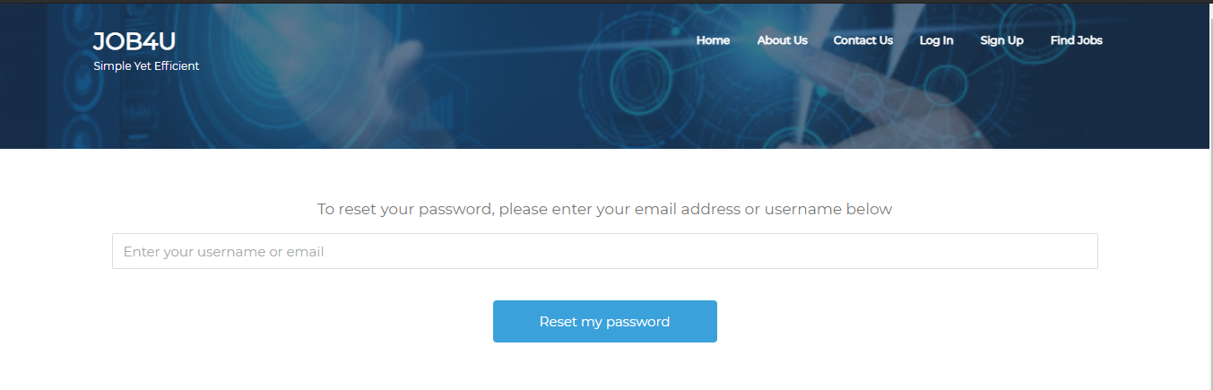

|  |  |  |
| --- | --- | --- |
| 1. Employers wish to customise their company profile and the roles they need to hire. | Allow them to provide company details, contacts and websites or social media links | Pass |

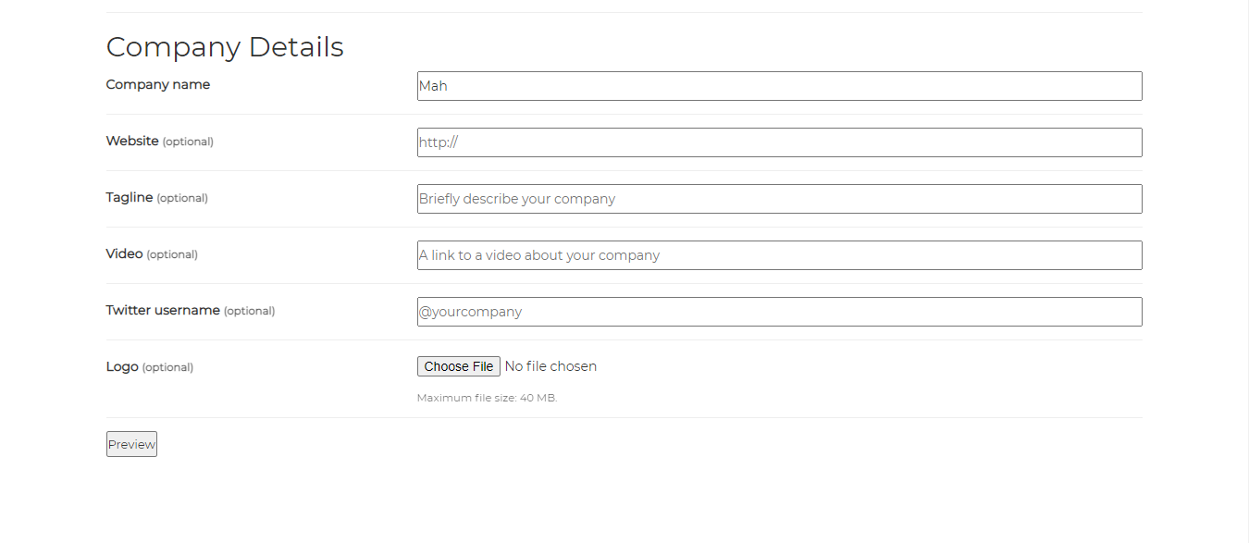

|  |  |  |
| --- | --- | --- |
| 1. Users wish to enter keywords to find what they want. | Keyword search engines are not just limited to occupation, but also location, job types (part-time, internship, full-time, contract), company name or skills required. | Pass |

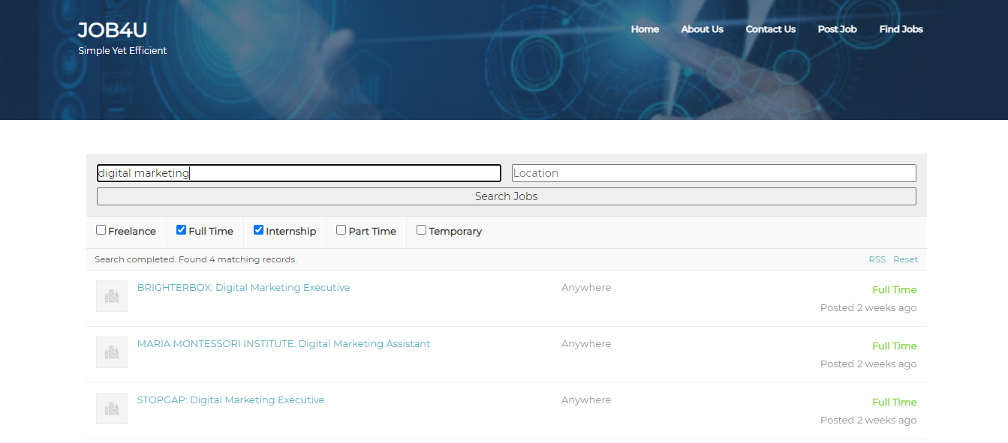

|  |  |  |
| --- | --- | --- |
| 1. Users wish to give feedback to our portal for any enquiry. | Feedback form will be provided to the user for any enquiry uses and some top FAQs answers are provided for their convenience. | Pass |

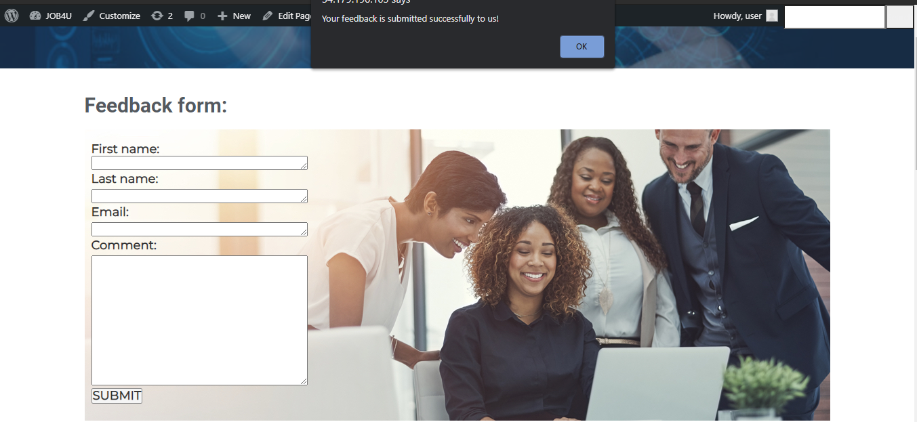

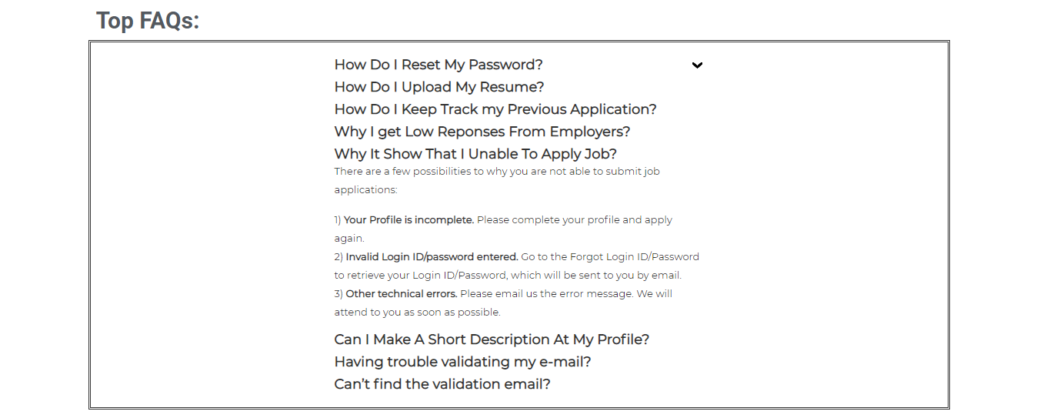

|  |  |  |
| --- | --- | --- |
| 1. Users wish their personal information to be protected. | Our platform will always be secure and updated frequently. Our terms and condition of our cookies will be stated clearly before they agree to sign up. | Pass |

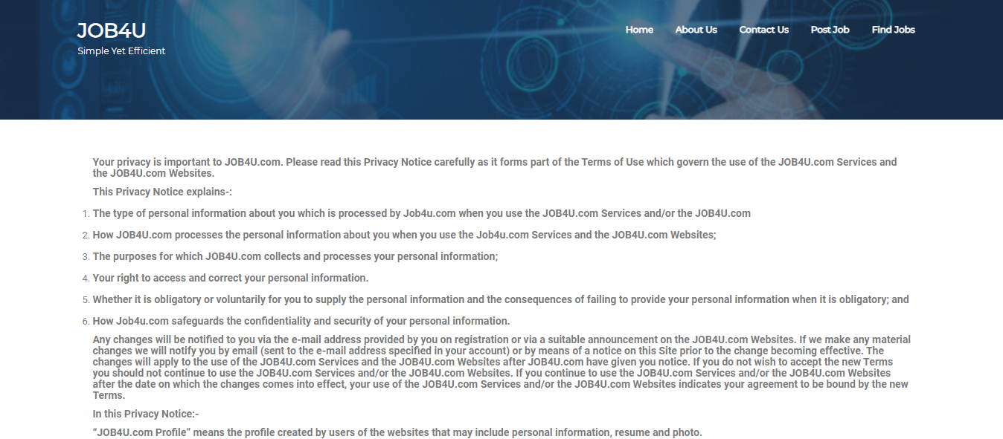



|  |  |  |
| --- | --- | --- |
| 1. Users wish to know what the new trends and news are through here. | Our platform will provide a stage for the newest within the country about employment. | Pass |



|  |  |  |
| --- | --- | --- |
| 1. Users wish to post jobs and details about it to attract job seekers | Our portal will provide a form to fill before posting jobs with company details and application requirements. | Pass |

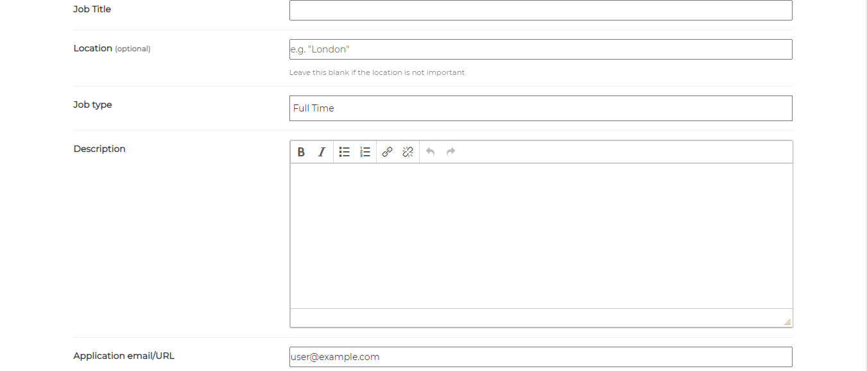

|  |  |  |
| --- | --- | --- |
| 1. Employer trying to post job with insufficient details Prompts to fill in all the necessary details of the job | Our portal will prompt employers to fill up necessary details or else cannot be posted. | Pass |

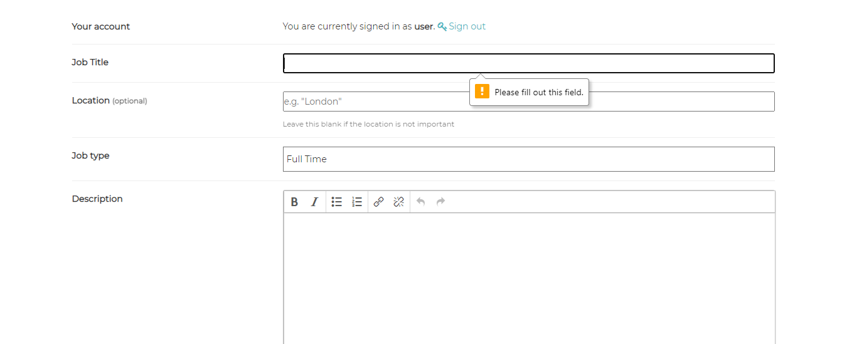

|  |  |  |
| --- | --- | --- |
| 1. User wish to preview to double confirm and press submit before posting jobs | Our portal will provide a preview look to decide to edit more before they want to submit. | Pass |

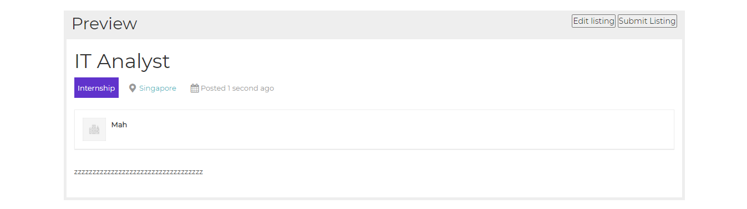

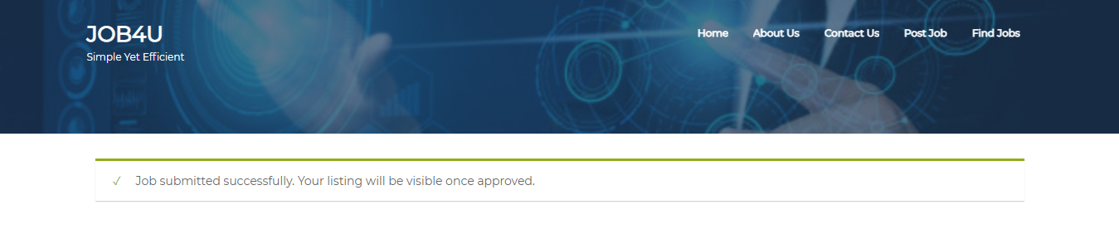

|  |  |  |
| --- | --- | --- |
| 1. Users with to log out from the profile | Redirects to the Homepage of the  Application for public view. | Pass |



|  |  |  |
| --- | --- | --- |
| 1. Users wish to view the details of selected posted jobs. | Our portal allows them to click in to see more information about selected jobs. | Pass |

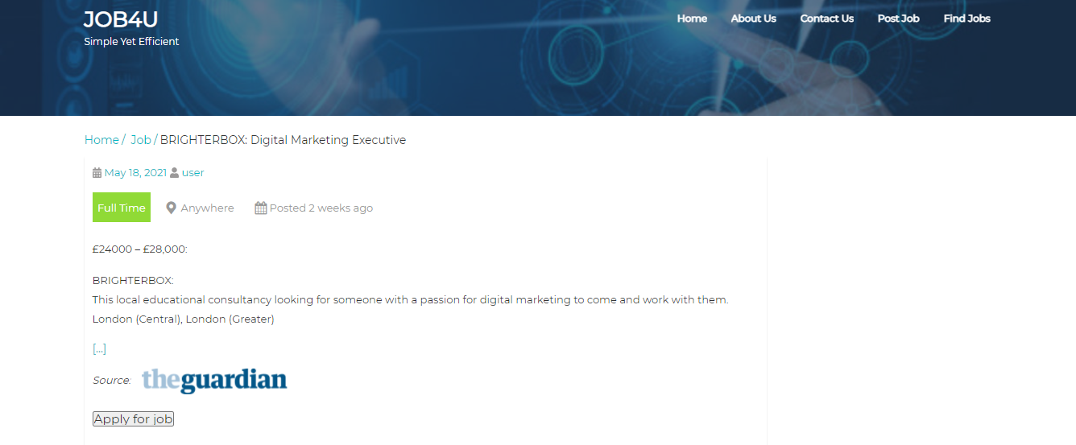

**External software libraries**.

Due to using WordPress to develop our website, we used many external software libraries or plugins that help us to reduce some workload specifically on the programming side.

* **Elementor**

Elementor is a free plugin that includes many widgets that are attractive and web responsive at the same time. As said before, the plugins usually reduce programming workload, and this is especially true for this plugin. Their widgets just require us to drag and drop the content into the block editor and just lets us be able to focus on the content we would like to deliver to the customers.

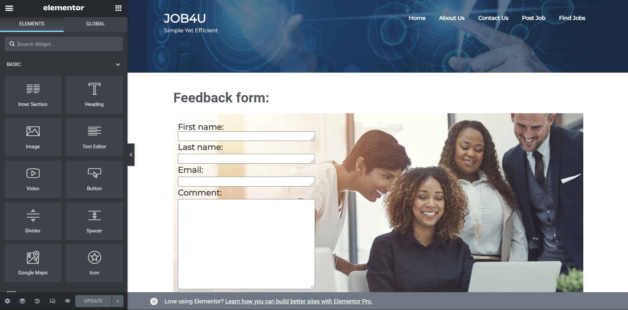

* **WP Job Manager**

WP Job Manager is a plugin that helps with managing jobs listings and has widgets to allow customers to submit potential jobs for review. They also provide a job database which allows us to easily check any jobs that have been submitted or are currently being shown to the public. The plugin also has shortcodes for widgets which again helps with the programming side and allows us to focus attention on dealing with any jobs that have been submitted but not yet approved.

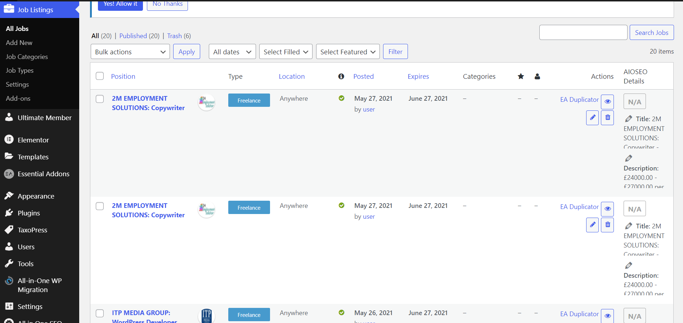

* **WP Job Manager - Go Fetch Jobs**

Go Fetch Jobs is a plugin that automatically populates the job database provided by WP Job Manager with real jobs using an RSS feed. As our website is new, there might not be any companies that would know about us nor be willing to spend their energy to post their job listings on our site. This automatic plugin allows our website to be recommended by job hunters as they might input that they heard about a particular job opening because of our website.

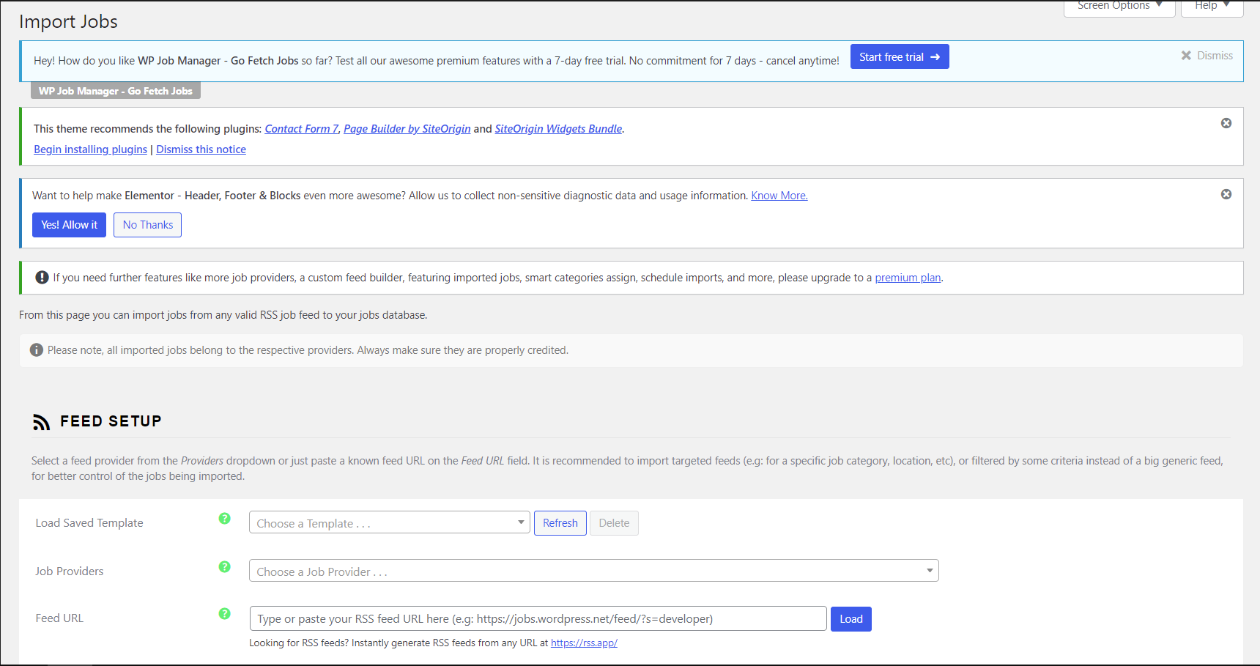

**Project development and release ICT infrastructure**.

1. **Configuration Management**

We are using GitHub for version control and configuration management. Team member Kum King Wye e has created a respiratory and invited the other members to join before we finish the project outline and start creating a website. Since we are familiar with it, we can upload and view our codes perfectly and it allows for branches as well. We also can commit as many as we can for better understanding and our lecturer also can access it for viewing the codes.

**Github link:** [**https://github.com/kkw123/CP3407_Assignment**](https://github.com/kkw123/CP3407_Assignment)

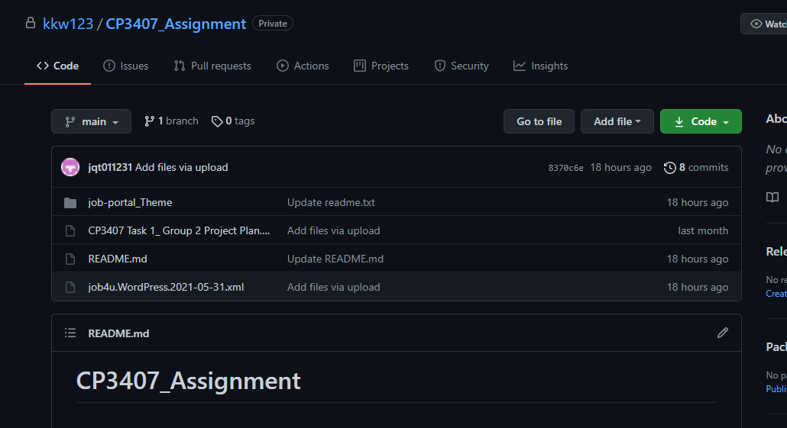

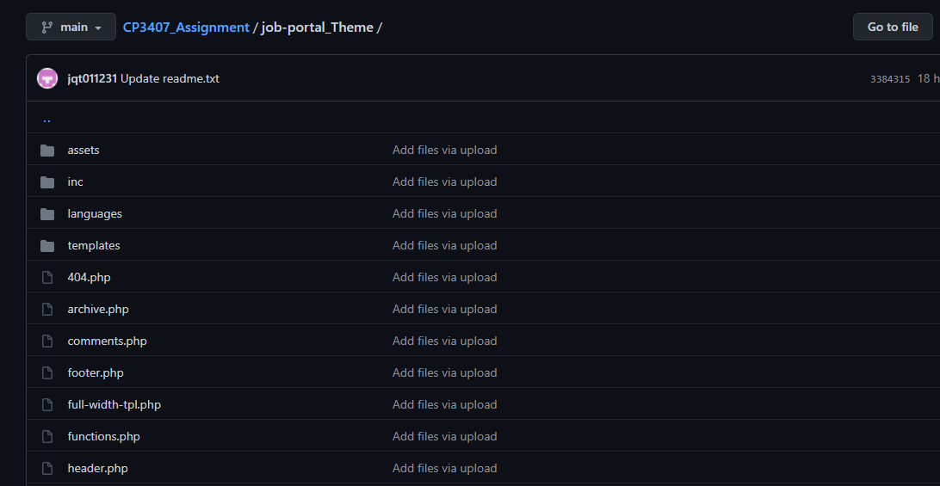

1. **Project collaboration tools.**

* **WhatsApp**

As this project requires teamwork, collaboration and communication tools are important to ensure the whole process performs well for a better outcome. Our main communication for chatting is WhatsApp group to arrange schedules and adjust our process. It also becomes a quick and efficient tool since we can reply and on call most of the time once we receive any notification.

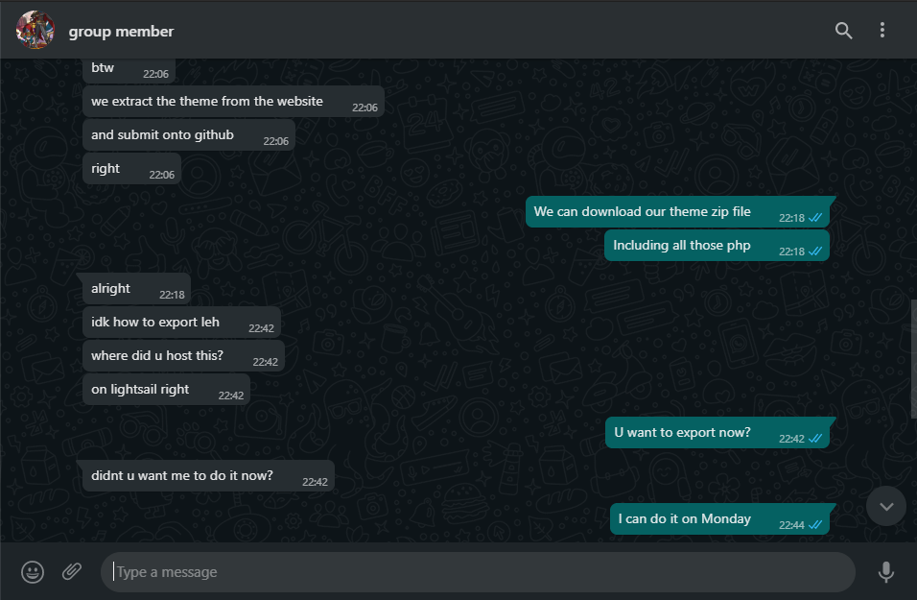

* **Google drive**

Google Drive is a file storage and synchronization service to allow us to share any zipped file and important documents there. It also allows us to store our practicals and previous assessments inside.

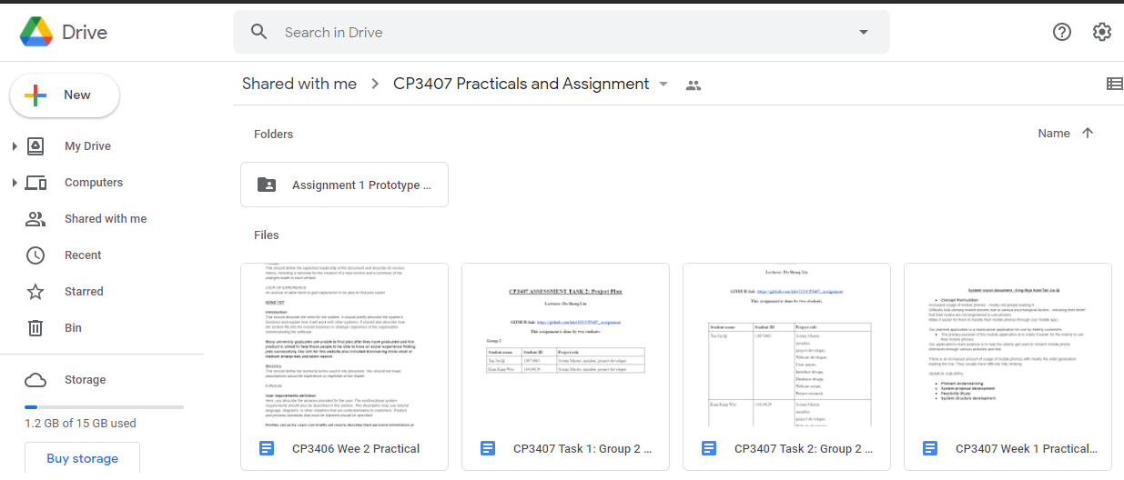

* **Google docs**

We can use Google docs in the drive to finish documents at the same time so that we do not need to send a copy to each other to edit. This can save a lot of time and energy.

**Google drive link:** [**https://drive.google.com/drive/folders/1xF5-PqIsKNpfx3rWHKidpGhJz7wnMgrs?usp=sharing**](https://drive.google.com/drive/folders/1xF5-PqIsKNpfx3rWHKidpGhJz7wnMgrs?usp=sharing)

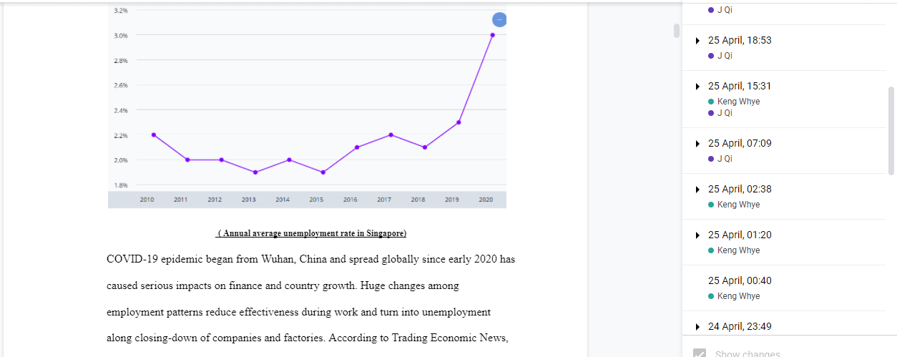

* **Trello**

We use Trello for a better organization and planning scope of our project. It helps us to observe our improvement and tasks by a glance as we conduct weekly stand up and lecturer’ feedbacks in there. We also note what we must do, what has been done and what is going to do to catch up with our activities.

**Trello link:** [**https://trello.com/b/DRncubVL/cp3407-group-2**](https://trello.com/b/DRncubVL/cp3407-group-2)

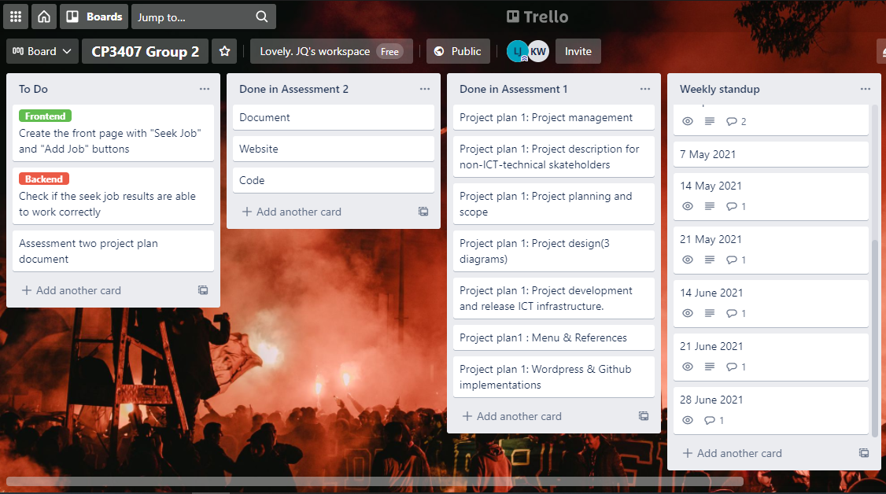

1. **Programming languages**

* **HTML**

HTML is a basic programming language for creating websites. We use it mostly for our content to enter descriptions. It allows the user to create and structure sections, paragraphs, headings, links, and blockquotes for web pages. Since it is easy and we are both familiar with it, we use them in our website structure.

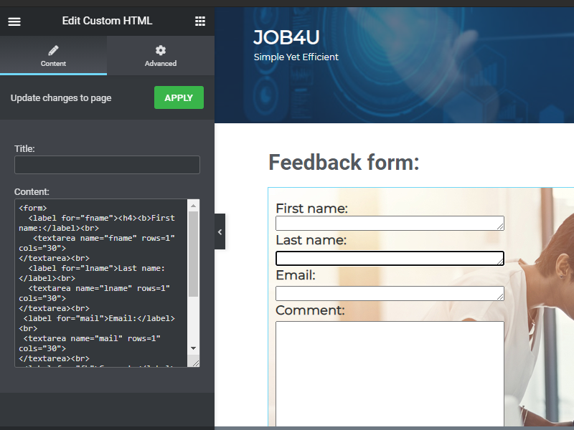

* **PHP**

PHP is the most important programming language that we used for our theme to make our dynamic contents and databases. We use these because they are easy, fast maintenance and compatible with operating systems to perform independently.

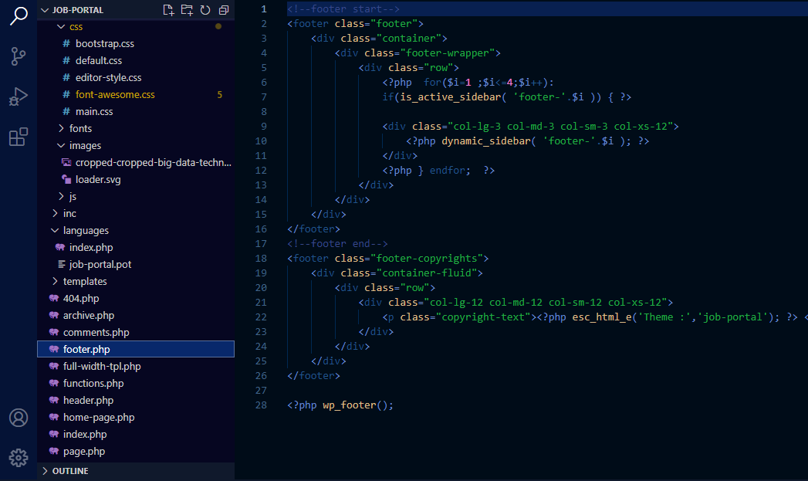

* **CSS**

CSS is like a collection of styles to make our website more attractive and colourful like layout or fonts. It also helps us to present our results in different sizes of screens. We use it because it can contain many designs at once with different viewers.

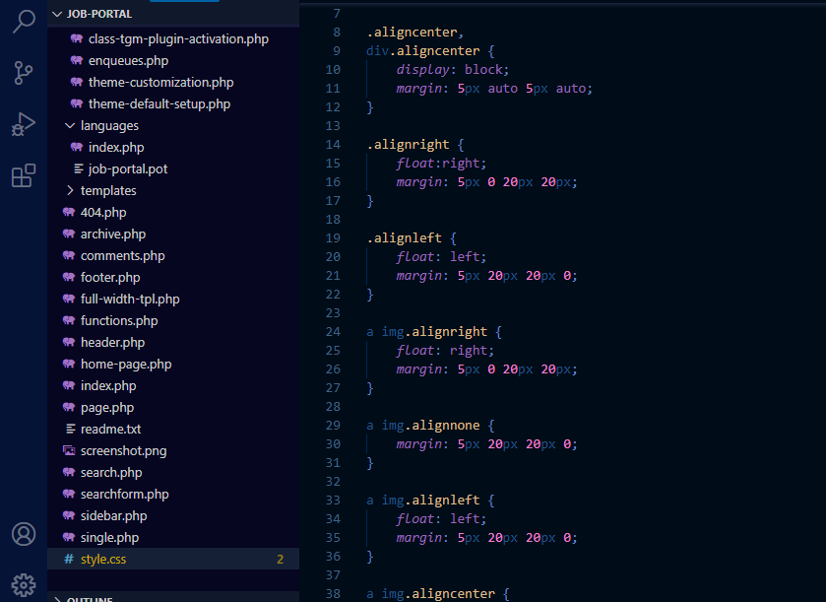

* **JavaScript**

JavaScript is treated as a client-side coding language which enhances and extends the capabilities of client-side coding.

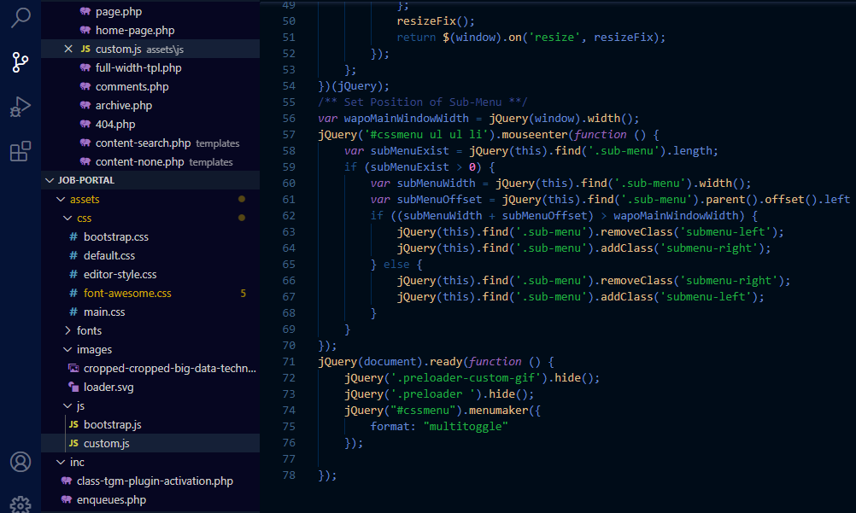

1. **Building tools**

|  |  |
| --- | --- |
| **Platform** | WordPress |
| **Operating system** | Window 10 (64 bits) |
| **Processor** | Intel core i7 8th generation |
| **Processor speed** | 3.40 Ghz |

**Procedure:**

* One of the group members is using Site Ground to log in and activate WordPress.
* Enter our domain name and password.
* Share the username and password to another group member to ensure that we can build together.
* Import our design theme and codes inside using Appearance -> Theme
* Download necessary plugins for our website such as Elementor and TaxoPress.
* Build in and adjust permanent header and footer for the website.
* Set up a new logo and enter our navigation menu bar for future pages.
* Build in afterwards following our prototype details and ready for our content.

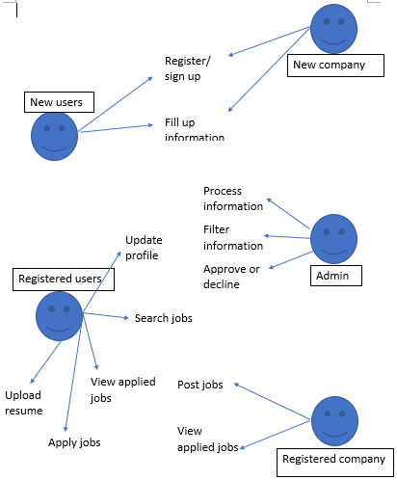

1. **How to set-up your development/release environment for a new team member.**

If the new member just wants to visit our site, can straight go with this link:

<http://54.179.196.103>

However, he can only view the site in public view without login.

If he wants to enter as an user and edit our dashboard, he can follow these instruction below:

* Go to the link: <http://54.179.196.103/admin>
* Will be redirect to this page

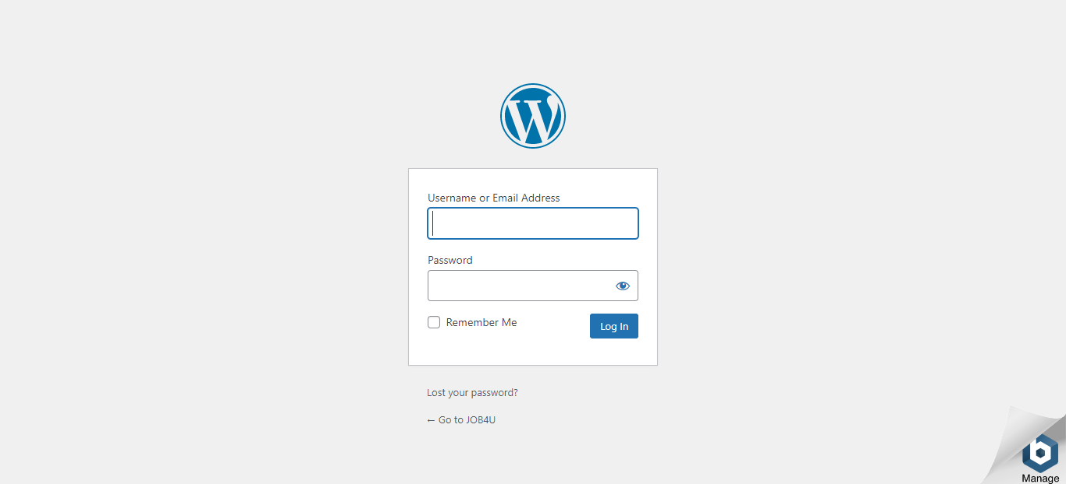

* Another option: go to the link login form <http://54.179.196.103/log-in/>
* Will be redirect to this page

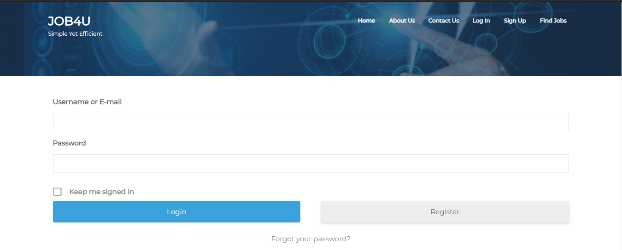

**Username: User**

**Password: tqRZqmqTLIo^jaaL3Rq@5%Z#**